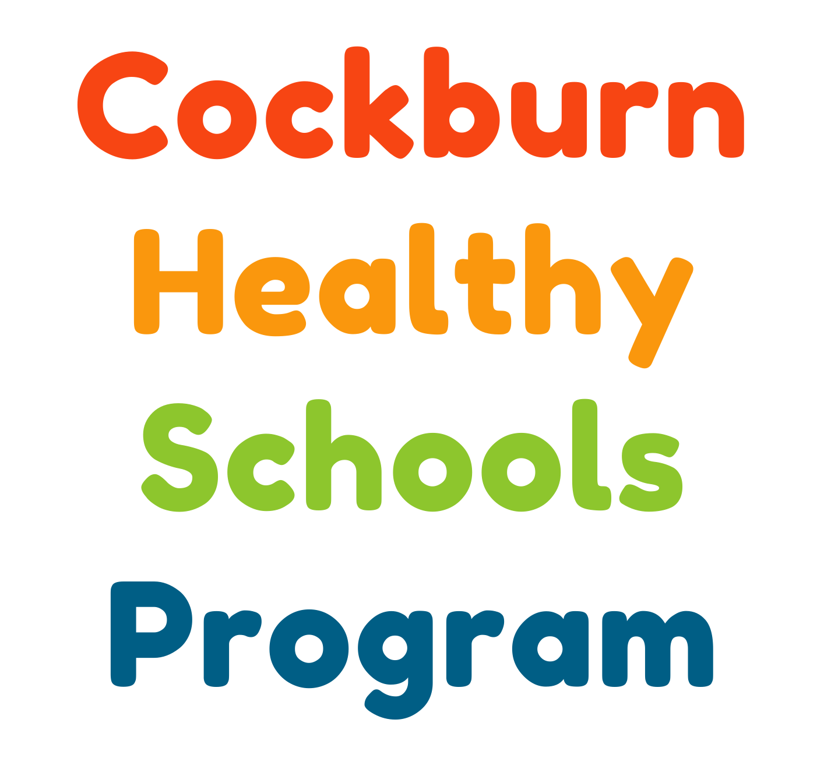

Jan – December 2025

Contents

Executive Summary 1
1.0 Healthy Schools Program Overview 2
1.1 Mentally Healthy WA 2
1.2 Packed with Goodness 2
1.3 KidSport 3
2.0 Nutrition Education 3
2.1 Nutrition Education Methods 3
2.2 Nutrition Education Resources 4
2.3 Nutrition Education Evaluation 5
2.3.1 Lesson one 5
2.3.2 Lesson two 6
3.0 Student evaluation 7
4.0 Teacher evaluation 8
5.0 Recommendations 9
6.0 Conclusion 10
Appendix I – Lesson Plan 1 – AGTHE, Chronic disease and diet link 11
Appendix II – Lesson Plan 2 – Label reading and healthy swaps 15
Appendix III – Lesson 1- Facilitator evaluation 18
Appendix IV – Lesson 2 – Facilitator evaluation 20
Appendix V – Teacher Evaluation 22

Executive Summary

The Cockburn Healthy Lifestyle Service (CHLS), established in 2017 by Cockburn Integrated Health (CIH), is an initiative aimed at supporting adults in adopting healthier lifestyles through access to resources and support. Those under the age of 18 are referred to the Optimal Weight for Life (OWL) program, offering healthy lifestyle support tailored for children and adolescents. Recognising gaps in community access to prevention services addressing overweight and obesity among school-aged children in Cockburn, CIH developed the Cockburn Healthy School Program (CHSP) to address these community needs.
The CHSP assists schools to improve student nutrition and health literacy while linking the demographic to existing health promoting services. This report evaluates the program’s emphasis on nutrition initiatives throughout the funding period.
CIH acknowledge key stakeholders, including Hardy Nutrition Dietary Consulting, Foodbank WA, KidSport, Mentally Healthy WA, Cancer Council WA, FreshSNAP, Curtin University, and the City of Cockburn.

1.0 Healthy Schools Program Overview
The Cockburn Healthy Schools Program (CHSP) is a local initiative aimed at improving nutrition knowledge and healthy lifestyle behaviours among primary school students within the City of Cockburn. The program initiated in 2021, where CHSP conducted a needs assessment across five primary schools—East Hamilton Hill, South Lake, Yangebup, Spearwood, and Phoenix—to identify key gaps in students’ nutrition literacy. This informed the development of a more targeted approach, enabling the program to focus on age groups most receptive to learning and maximise its impact.
Since its inception, CHSP has worked collaboratively with schools and community partners to deliver tailored, evidence-informed education that supports student wellbeing. Such key agencies include Cancer Council WA, Mentally Healthy WA, FreshSNAP, KidSport, and Hardy Nutrition and Dietary Consulting. These partnerships allow the program to provide comprehensive classroom sessions, access to specialised resources, and practical support for schools.
From 2021 to 2025, CHSP reached 42 primary schools, delivering 412 sessions to over 4,200 students. In 2025, a mid-program assessment was conducted at Phoenix and Aubin Grove Primary Schools to evaluate current health literacy levels among Year 4–6 students, with findings aligning closely with the 2021 baseline. This continuity reinforces the program’s ongoing relevance and its role in addressing key health and nutrition education needs across the region.

1.1 Mentally Healthy WA
The Act-Belong-Commit Mentally Healthy Schools Program supports the mental health and wellbeing of students, staff, and the wider school community. It promotes positive mental health habits, reduces stigma surrounding mental illness, and empowers staff to create supportive learning environments. Participating schools receive resources and guidance to integrate Act-Belong-Commit principles into classroom activities, with a focus on resilience, mindfulness, and mental health literacy. All schools involved in the CHSP were encouraged to participate in this initiative.

1.2 Packed with Goodness
Packed with Goodness is a Cancer Council WA initiative designed to support parents in preparing nutritious lunchboxes. The free 90-minute sessions are delivered either in person or online and focus on practical, evidence-based strategies to promote healthy eating in school-aged children. All CHSP-participating schools were notified of the program and encouraged to book a session for their school community.

1.3 KidSport
KidSport is a Western Australian Government initiative that provides up to $500 per year to support children aged 5–18 from low-income families to access community sport. The funding covers registration fees, uniforms, and equipment, helping reduce financial barriers to participation. Flyers, application forms, and electronic resources were distributed to all CHSP-participating schools and shared with parents and caregivers.

1.4 FreshSNAP
FreshSNAP provides free advisory and consultation services and resources to support teachers, school canteens, school leadership teams and parents to create healthier environments for Western Australian children and adolescents. All CHSP-participating schools were informed of the free course designed for school educators who want to boost their confidence in delivering nutrition education and support student wellbeing.

2.0 Nutrition Education
In 2025, a total of 38 nutrition education lessons were delivered at four primary schools within the City of Cockburn as part of the CHSP, reaching 527 students. Lessons were designed to be age-appropriate, aligned with students’ literacy levels, and integrated with the existing school health curriculum.
The revised content was delivered by a CHLS Accredited Practising Dietitian, assisted by student nutritionists and dietitians from Curtin University. Each participating class received two sessions, with the goal of improving knowledge and practical skills related to healthy eating among students in Years 5 and 6.

2.1 Nutrition Education Methods
As part of the planning process for nutrition education delivery, the CHSP Coordinator contacted local primary schools within the City of Cockburn to assess interest in participating in upper primary nutrition lessons. A needs assessment was carried out with four selected schools (Phoenix Primary School, Aubin Grove Primary School, Yangebup Primary School and Harmony Primary School) through a combination of email correspondence and phone consultations.
The assessment gathered information on class sizes, student literacy levels, prior nutrition education, teacher understanding of nutrition topics, and expectations for the upcoming lessons. Both schools reported similar levels of existing nutrition knowledge among students. Although both schools had previously taught the Australian Guide to Healthy Eating, a similar lesson was requested to reinforce learning. Students have not yet learned nutrition label reading in both schools.
Lesson one primarily covered the AGTHE, detailed in the lesson plan in Appendix I. the session began with a group activity where students tested their knowledge through an AGTHE sorting exercise. They then explored the five food groups, discussing their importance, daily serving recommendations, and appropriate serving sizes. The lesson shifted focus to discretionary foods, emphasising the effects of excessive salt, sugar and fat consumption. Students participated in a hands-on activity that classified different types of fat and the foods that belong to each category. These discussions and activities aimed to assess the children’s understanding of healthy eating practices for pre- and post-evaluation.
Lesson two centred on reading food labels, as outlined in the lesson plan in Appendix II. Students learned to interpret various health claims made by food companies and assess whether a food product is healthy. The main activity involved hands-on label reading, which was adapted based on the level of assistance the students required to read nutrition labels correctly. Like the first lesson, this session was interactive, featuring group work and class discussion.

2.2 Nutrition Education Resources
Existing resources from the CHSP were utilised for the student education lessons. This included the AGTHE felt activity, images of food, and empty food packaging. Each student received one recipe book (either Let’s Cook recipe books #1, Let’s Cook recipe books #2, or Best of Healthy Recipes for All) developed by Foodbank WA.

2.3 Evaluation methods
A range of methods were used to assess the effectiveness and relevance of the nutrition lessons. Lesson evaluation forms were completed by the CHSP coordinator, student dietitians and nutritionists, during the lessons (see Appendix III and Appendix IV for full details). The evaluation forms focused on gathering common student responses, common nutrition misconceptions, the level of nutrition knowledge of the class, and the level of assistance required to complete group activities.
Additionally, teachers were invited to complete an evaluation questionnaire consisting of seven questions at the end of the second lesson. Six questions used a Likert scale ranging from strongly agree to strongly disagree, while the seventh provided space for additional comments or suggestions (see Appendix V). The questionnaire focused on key areas including the appropriateness of session timing, the quality and relevance of the educational content, overall satisfaction with the delivery, and perceptions of the program’s potential to positively influence students' eating behaviours.

2.3 Nutrition Education Evaluation

2.3.1 Lesson one
Students’ level of knowledge of the five food groups varied. Some students organised the chart into groups of “very healthy”, “healthy”, “unhealthy”, “very unhealthy” and “not sure”, while others were able to correctly identify the five food groups. Commonly misplaced foods included beans, margarine, butter, eggs, deli meats, frozen vegetables and nuts. Other common mistakes seen across the schools included students placing the sometimes foods into their own food group within the chart and subsequently placing fruits and vegetables or protein and dairy into one group. After class discussion on the five food groups every group was then able to place all foods into the correct food category.
All students understood the health outcomes of consuming excessive discretionary foods, as demonstrated by the common responses in figure 1 below. The students’ understanding of excessive sugar and fat consumption was more developed compared to salt. Most students (>600%) were able to identify specific chronic diseases that are related to excessive discretionary food consumption.
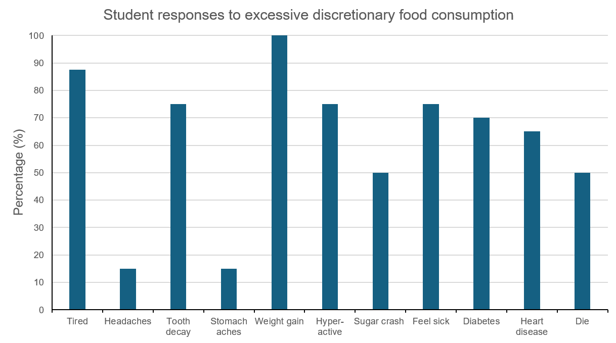
Figure 1. Student responses to excessive discretionary food items.
During the nutrition education sessions, students demonstrated varying levels of understanding across key dietary topics. Discussions revealed that students were generally familiar with different types of sugar, with most correctly identifying naturally occurring sugars in fruit. Many understood that sugar provides energy for physical activity and agreed that it enhances the taste of food.
However, knowledge around salt was limited. Students recognised its role in causing thirst and dehydration but not its role in maintaining blood pressure or preventing muscle cramps during exercise.
In contrast, understanding of dietary fats was more developed; students broadly acknowledged the importance of fat for organ protection and energy. Additionally, students from both schools categorised “healthy fats” and “unhealthy fats” based on the level of food processing.
Table 1. Foods commonly misplaced in Activity 2.
Commonly misplaced foods | Foods correctly identified
Commonly misplaced foods | Healthy fats | Unhealthy fats
Olive oil  Peanut butter  Coconut oil  Tinned tuna  Cream  Salami | Avocado  Nuts  Full cream milk | Meat pie  Chicken drumstick with skin on  Butter  Donuts

2.3.2 Lesson two
The second lesson included a recap discussion to reinforce information from previous lessons. The session featured class discussion on health claims found on food packages, group activities focused on label reading, and practical applications of learned skills for creating healthier lunchboxes.
At the start of the lesson, students were asked to recall the five food groups, recommended daily servings and serving sizes. Across four schools, 100% remembered the five food groups correctly, 75% recalled the recommended daily servings and 82.5% remembered the serving sizes of each food group.
When asked to brainstorm common nutrition claims on food products, students identified the following claims:
- Gluten free
- Full fruit juice
- No sugar or artificial flavours
- Vegan
- High protein
- Low fat/fat free
- No added sugar
- Organic
- Made in Australia
- Health star rating
- Expiry/use by date
This knowledge was applied to Nutri-Grain packaging, where students identified health claims and voted on whether it was a discretionary food or part of the core food group. The identification of Nutri-Grain as a discretionary food increased from 60% to 100% after learning about label reading.
In the label reading activity, students were divided into five or six groups, each tasked with assessing a different category of food labels to determine whether the items were healthy. The varying literacy levels within the classrooms impacted the assistance required, with 90% reading the food labels correctly and 60% successfully ordering foods from healthiest to least healthy.

3.0 Student evaluation
Students demonstrated a high level of engagement during group discussions and group activities. At the end of each lesson, students were provided the opportunity to reflect on their learning and ask questions.
Student responses during these reflections demonstrated a solid understanding of key concepts, including food group classification, recommended daily servings, and serving sizes. Additionally, students were able to articulate how to identify sources of healthy and unhealthy fats, reinforcing the effectiveness of the lesson content and delivery. Several students also used the recipes provided to try out various recipes, indicating engagement with the healthy schools program and curiosity to try out new recipes.
All students demonstrated effective label reading skills, aiming for less than 10g of total fat, less than 1.5g of saturated fat, and less than 5g of sugar per 100g. Many students reported increased knowledge and behavioural changes, such as making their own energy balls, sharing their new skills with family members, identifying the number of vegetable serves consumed daily, and choosing healthier snacks.

4.0 Teacher evaluation
The rate of completion of the teacher evaluation forms was 92.5%. As shown in Table 2, the satisfaction level for the lesson was high, with no responses indicating disagreement.
Qualitative feedback provided guidance on areas for improvement and strengths of the current program. Among the feedback obtained, the following themes were deduced:
- The delivery of the healthy lessons by a health professional was impactful
- Label reading activity provided students with practical skills and was well-received
- More group discussions on label reading strategies was requested
- More lunchbox recommendations tailored to the food choices of 10–12-year-olds was requested
Table 2. Teacher evaluation feedback
Evaluation Question | Responses & No.
 | Strongly Agree | Agree | Neutral | Disagree | Strongly Disagree
Do you think the lessons run at an appropriate time length? | 70% | 30% | - | - | -
Was the information delivered easy to understand? | 70% | 30% | - | - | -
Do you think the lessons delivered were at the appropriate class level? | 70% | 30% | - | - | -
Were the lessons interesting and helpful? | 58% | 32% | 10% | - | -
Do you think the students will change their eating habits as a result of what they have learnt during the program? |  | 46% | 54% | - | -
How likely are you to recommend this program to others? | 60% | 30% | 10% | - | -

5.0 Recommendations
- Focus on healthy swaps and what that would look like in a lunch box or at breakfast
- Have food models or use everyday objects to visualise portion sizes that align with the healthy plate model
- Include another hands-on activity during session one to cement learning and make the lesson more engaging
- Have a bigger focus on healthy swaps throughout both sessions. Snacks are often food children have more control over, thus by providing them with more knowledge around healthy swaps they may be able to start implanting healthy changes in their lives.
- Provide examples of healthy snack alternatives so students can visualise alternative options.
- Improve evaluation methods: potentially have a survey link for both students and teachers fill out.
- Investigate what could improve student application of these lessons, as teachers indicated most students would probably not implement what they learnt.

6.0 Conclusion
In conclusion, the CHSP successfully reached 527 students across four schools in 2025. These schools were selected to target children facing significant socio-educational disadvantages in the local area.
The interactive activities demonstrated strong knowledge retention and comprehension among the students, with teacher feedback reflecting high levels of satisfaction with the sessions. The program’s success highlights the critical role of nutrition education in primary schools, emphasising its impact on establishing healthy habits early in life. Continued funding and expansion would enable the CHSP to reach an even greater number of children across the City of Cockburn, fostering a healthier future for the entire community.

Appendix I – Lesson Plan 1 – AGTHE, Chronic disease and diet link
CHSP Lesson Plan Session 1 – AGTHE, Chronic disease and diet link
Unit/Topic: Nutrition Date:

Key Learning Area: Nutrition (health) Year Level: 5 & 6
Outcomes:

LESSON OUTCOME:
The Year 5 and 6 curriculum supports students to develop knowledge, understanding and skills to create opportunities and take action to enhance their own and others' health, wellbeing, safety and physical activity participation.
- Being healthy, safe and active: plan and practice strategies to promote health, safety and wellbeing.
By the end of the session’s students should be able to confidently identify each of the five food groups and list at least one health benefit received from eating foods from this group. Students will also understand how many serving sizes of each category they need each day, and what this looks like.
Students will also understand the correlation between poor diets and chronic disease with a specific focus on sugar, salt and fat. While also understanding the importance of each of these minerals and nutrients.

LESSON STRUCTURE:
Time | Introduction (Set): | Resources
2 min  5 min | Introduction:  Who am I, why I am here, what we are going to learn?  Icebreaker.  Option 1: What is your favourite cuisine, stand in the different spots around the classroom (Indian, Mexican, Chinese, Italian, other).  Option 2: hands up whose favourite cuisine is …  Option 3: go around the room. | Slides (1-2)

Time | Main Content: | Resources
5 min  10 min  5 min  10 min  10 min | AGTHE Activity Part 1:  Split into groups the students will be given a large empty AGTHE chart and cut outs of different foods. They will then be given five minutes to sort out the foods into the correct category.  AGTHE:  - How many serves of (each individually) should we be having every day? And what does that look like in real life (ie 2 serves of fruit = one apple and two apricots, or one banana and a handful of berries)  - Highlight the importance of each category and what benefits they provide for our health using power point.  AGTHE Activity Part 2:  - Each group will then be given the opportunity to look back at their AGTHE chart and fix anything that might have been in the wrong spot.  - They will then work together to complete the match up sheet for serving sizes.  Who has tried some of the less common foods from some of these food groups? (think polenta, quinoa, tofu). What influenced you to try these foods?  Diet and chronic disease relationship:  - What happens when we don’t eat all five food groups and eat mostly food from our ‘sometimes’ food group?  - What is the importance of sugar? What happens when we eat too much of it?  - What is the importance of Fat? What happens when we eat too much of it?  - What is the importance of salt? What happens when we eat too much of it?  Different types of fat:  - Explain that we have two types of fat: Saturated and unsaturated fat. Unsaturated fat is really good for us, it has all the healthy fats that are important for our brain, energy and insulation. Saturated fat is the not so good fat which can cause the chronic diseases we just discussed.  Activity 2 – fats  - Each group is given a handout of foods containing fats. They are to sort these into two categories. Healthy fat and un-healthy fat.  - Finish off with group discussion explaining that unhealthy fats often come from animal products such as cream. And coconut is an exception. Healthy fats come from our plant sources and from fish. | AGTHE activity part 1:  Empty chart  Laminated food items  Slides (4-8)  AGTHE activity Part 2:  Laminated serving requirements  Laminated health benefits  Slides (10)  Activity 2:  Laminated healthy and unhealthy food sources of fat.

Time | Conclusion: | Resources
5 min | Quick recap of session.  What are the five food groups?  What happens when we eat too much sugar?  What happens when we eat too much fat?  What happens when we eat too much salt?  Handout foodbank recipe books and encourage students to go home and try a recipe and we will check in with them next week to see how it went.
Resources
(Include equipment required for class and/or for teacher preparation)
- Lunch box handout
- Food packages
- Corresponding faces (green, orange and red)
- AGTHE activity: charts, foods, health benefits

Evaluation
In class evaluation:
- noting the progression of the student’s ability to successfully read and order food labels
- Assessing the food swaps which children consider to be a healthier choice

Post evaluation:
- Interactive online quiz assessing knowledge

Food Group | Health Benefit
Vegetables | - Give us vitamins and fibre that keep us healthy  - Decreased risk of CVD  - Decreased risk of site-specific cancers  - Decreased risk of Type II Diabetes  - Reduced risk of weight gain
Fruit | - Give us vitamins and fibre that prevent disease  - Reduced risk of coronary heart disease  - Reduced risk of stroke  - Reduced risk of weight gain (2 serves only)  - Some site-specific cancers
Grains and Cereals | - Give us energy and fibre to help digestion  - Reduced risk of CVD  - Reduced risk of Type II Diabetes  - Reduced risk of weight gain  - Reduced risk of colorectal cancer
Protein | - Give us protein and iron for strong muscles and blood  - Red meat 100-120g/day increases risk of colorectal cancer  - Consumption of fish more than once a week decreases risk of dementia  - Red meat increases risk of renal cancer and CVD  - Consumption of nuts decreases risk of cholesterol
Dairy | - Help us grow strong teeth and bones  - Reduced risk of heart disease and myocardial infarction  - Reduced risk of stroke  - Reduced risk of hypertension  - Reduced risk of site-specific cancers  - Reduced risk of Type II Diabetes  - Improved bone mineral density

Appendix II – Lesson Plan 2 – Label reading and healthy swaps
Unit/Topic: ________________________ Date:

Key Learning Area: Nutrition (health) Year Level: 5 & 6
Outcomes:

LESSON OUTCOME:
The Year 5 and 6 curriculum supports students to develop knowledge, understanding and skills to create opportunities and take action to enhance their own and others' health, wellbeing, safety and physical activity participation.
- Being healthy, safe and active: plan and practice strategies to promote health, safety and wellbeing.
By the end of the lesson students will be able to successfully read and comprehend food labels with a specific focus on sugar, salt and fat content. Students will be able to compare food products and determine what are healthier options.
Students will be able to determine healthier swaps for some of their everyday foods.

LESSON STRUCTURE:
Time | Introduction (Set): |  | Resources
Reintroduce yourself.
Ask if anyone went home and tried any of the recipes from the recipe booklet we handed out at the end of the last session?

Who can remember what we learnt last week:
Go over key points (record answers):
- Five food groups
- Diet and chronic disease relationship
Sugar – needed for energy. Too much will lead to diabetes, behaviour issues, weight gain, bad teeth
Salt – needed for muscles and blood pressure, too much will cause increased BP, heart disease
Fat – needed for insulation, hormones and energy. Too much will lead to weight gain, CVD and some site specific cancers
- Healthy vs unhealthy fats
Time | Main Content: | Resources
Activity 1.1: Lunch Box Activity – Get students to fill out lunchbox/daily food with what they had in their lunch box today (or what a normal day would look like).

Go through Slides on food label reading.

Activity 2 - Food label reading:
Split into five groups. Explain that you want the students to work together to put the smiley faces with the fat/sugar/salt content in each food product according to the guidelines.
Once this is completed get students to rank their food items in the order they think is healthiest to least healthy. Edi: and share this with the class
Once this is done get students to move around the classroom and look at what the other groups have done.
Get everyone back together and discuss if anyone was surprised by what they saw, if anyone had any questions.

Activity 1.2 - Students then to look again at their lunchbox activity and have a look to see if there might be any swaps they could make to have a healthier lunchbox. Using their imagination, the knowledge they just learnt about snacks/foods and the AGTHE.
Edit: hold up lunch box image/added sugar intake (visual)

Time | Conclusion: | Resources
Quick recap of session.
What are we looking for in a food label?
- Sugar > 5 g / 100g
- Fat > 3 g / 100g
- Sat Fat > 1.5 g / 100g
- Salt/sodium >120 mg / 100 g
What might be some healthy swaps we could do in our lunchboxes?

Time for final questions.

Resources
(Include equipment required for class and/or for teacher preparation)
- Lunch box handout
- Food packages
- Corresponding faces (green, orange and red)

Evaluation
In class evaluation:
- noting the progression of the student’s ability to successfully read and order food labels
- Assessing the food swaps which children consider to be a healthier choice

Post evaluation:
- Interactive online quiz assessing knowledge

Appendix III – Lesson 1- Facilitator evaluation
Cockburn Healthy Schools Program
Session 1 Evaluation
During the Session:
Activity 1.1 - Starting foundation knowledge of AGTHE:
Vegetables

Fruit

Grains and Cereals

Dairy

Protein

Activity 1.2 - How much change did the students need to make to their chart:

Collect completed matching activity sheets.
What happens when we don’t eat from the five food groups and we eat more of the sometimes food items?

Why do we need sugar?

Why do we need salt?

Why do we need fat?

What can you tell me about fat?

Activity 2 – fat:
Note how students went with the fat activity and how much assistance they needed.

Appendix IV – Lesson 2 – Facilitator evaluation
Cockburn Healthy Schools Program
Session 2 Evaluation
During the Session:
Session 1 Recap – record answers:

What are food labels and what should we look for?

What are some health claims we might find on food packaging?

Activity 2 – label reading:
Note how students went with the activity and how much assistance they needed.

Activity 1.2 – lunchbox swaps:
Make note of conversations students had around swaps. Collect lunchbox activity.

Appendix V – Teacher Evaluation
